Serverless Web Application on AWS

Objective: Build a serverless web application using AWS Lambda, DynamoDB, and S3. The application will allow users to perform CRUD (Create, Read, Update, Delete) operations on a DynamoDB table.

**The project involved the following components:**

* AWS Lambda: For serverless backend logic.
* Amazon DynamoDB: As a NoSQL database for storing items.
* Amazon S3: For hosting the web application's static files.
* Amazon CloudFront: To deliver the web content with low latency.

# Architecture:

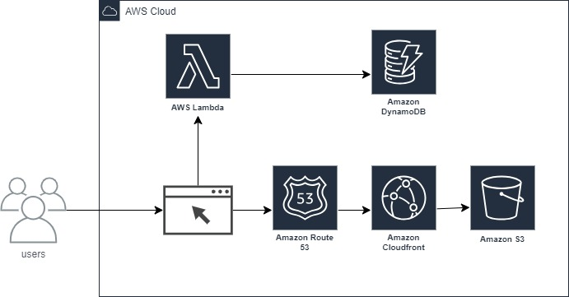

# Steps to Build the Project:

**Create a DynamoDB Table:**

* Set up a DynamoDB table to store the items with appropriate key schema and attributes.

**Build a Lambda Function for CRUD Operations:**

* Create: Implement Lambda functions to insert new items into the DynamoDB table.
* Read: Implement Lambda functions to fetch items from the DynamoDB table.
* Update: Implement Lambda functions to modify existing items in the DynamoDB table.
* Delete: Implement Lambda functions to remove items from the DynamoDB table.

**Host Static Files on S3:**

* Upload the web application's static files (HTML, CSS, JavaScript) to an S3 bucket.
* Configure the S3 bucket to host a static website.

**Create a CloudFront Distribution:**

* Set up a CloudFront distribution to serve the S3-hosted static files with low latency and improved security.